|  |  |
| --- | --- |
|  | **SR UNIVERSITY**  **Campus Warangal** |
| **Program:** II - B.Tech (CS& AI) |
| **Professor(a):** Dr. Venkataramana Veeramsetty, Professor |
| **Department:** Computer Science and AI **Semester:** I |
| **AI Assisted Coding - Lab Test 1 - Set A** |
| Instructions:   1. Use AI Tools like VScode+Github Copilot and Cursor AI for code generation 2. This Assignment will be evaluated for 15 Marks (10 Marks for Tasks and 5 Marks for viva based on regular lab activities) 3. Students need to submit assignment through canvas before due date 4. Students who are absent for lab will receive 0 Marks | |

1. Write a Python code to calculate the sum of odd and even numbers in a given list using GitHub Copilot along with VS Code. Use zero shot prompting

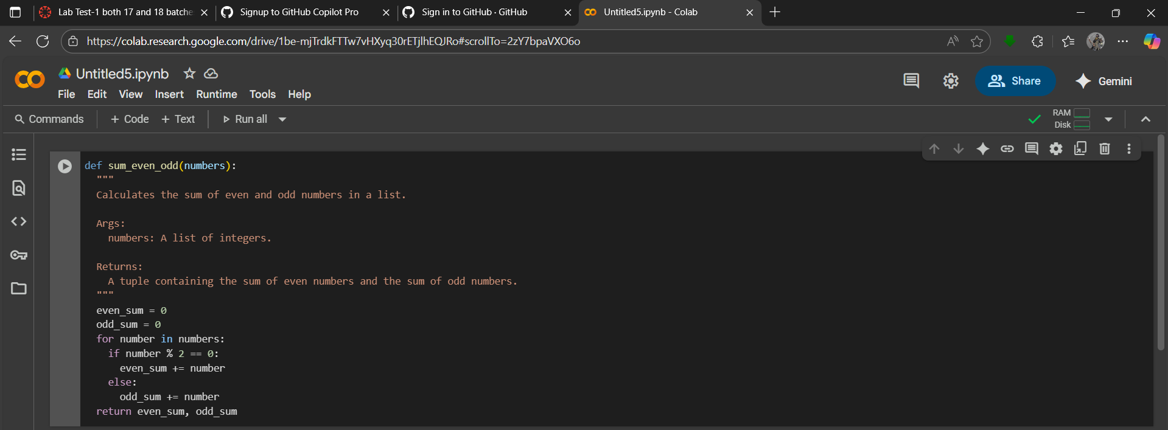PROMPT:-- Write a Python function that takes a list of integers and returns the sum of even numbers and the sum of odd numbers separately.

1. Write a Python code for given a list of integers, remove duplicates and print the sorted result. GitHub Copilot along with VS Code. Use one shot prompting.

PROMPT:-- Create a Python function that takes a list of integers, removes duplicates, sorts the result, and prints it.

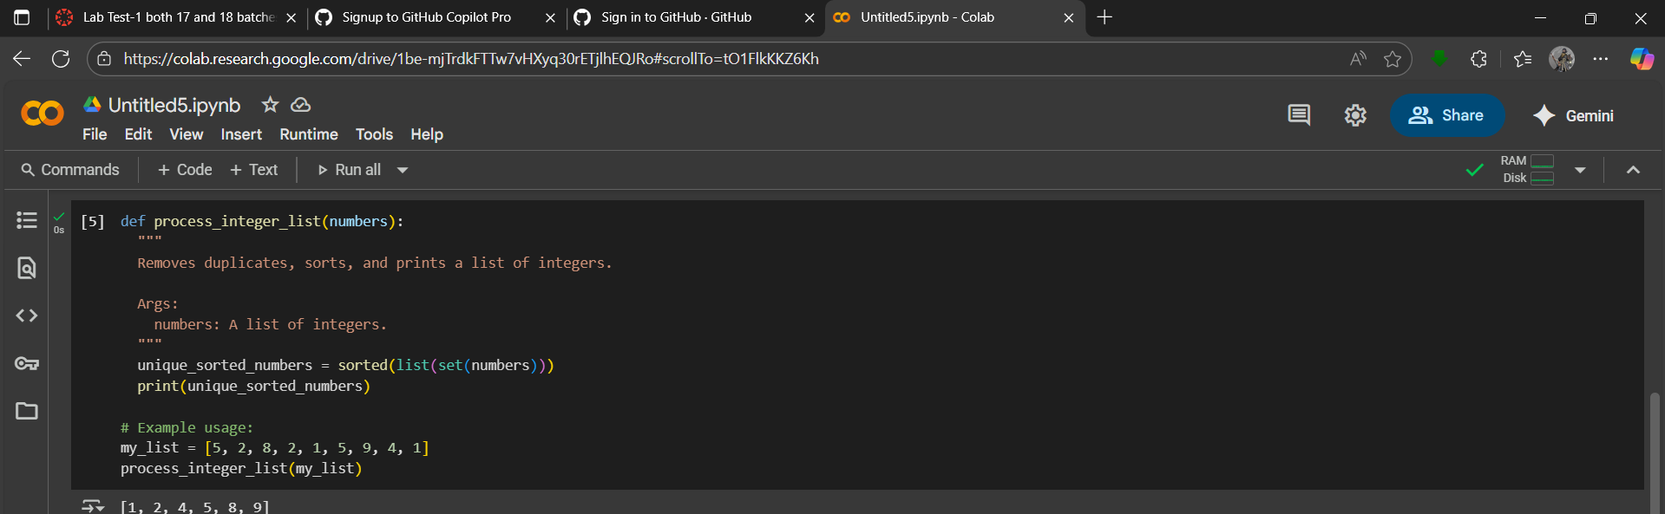

**GITHUB LINK:-**

**M.vijay kumar**

**2403A51445B-18**

**Date:** 2025-08-14